Reston
Harvest Show
23rd Sept 2023

Reston village hall
Schedule available on restonscotland.com
Everyone welcome!

Admission: By donation,
Doors open to the public at 1.30pm
Afternoon Tea, coffee, cakes
Raffle
Prize giving 2.30pm
Adult and children’s classes
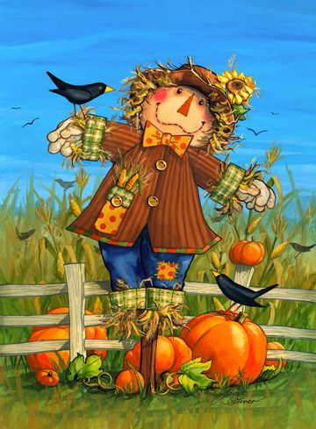
This Photo by Unknown Author is licensed under CC BY-NC-ND
Entries on the day: 30p per class
Group A- Pre School classes 5 and under
- Finger Painting
- Favourite teddy
- X3 chocolate crispy cakes

Group B- 6-10yo classes
- Pebble painting
- My favourite animal photograph
- X3 chocolate chip cookies

Group C- 11-16yo classes

- A “be real photo”
- A piece of handmade jewellery
- X3 Butterfly cakes
This Photo by Unknown Author is licensed under CC BY-NC
Group D- Adult classes
(Baking)
- 4 Fruit scones
- Bakewell tart
- Lemon drizzle
- 4 pieces of uncooked traybake
- Coffee and walnut cake

Group D- Adult classes
(produce)
- Any home-grown vegetable
- Any home-grown fruit
- Any homemade jar of jam
- Any homemade jar of chutney
- A fruit cordial
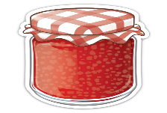
Author is licensed under CC BY-NC
Group D- Adult classes
(Crafts)
- Any house plant
- Any hand knitted item
- A hedgerow themed flower arrangement
- A water themed photograph
- A piece of history
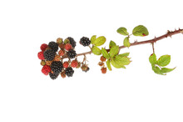

Schedule available on:
restonscotland.com
Reston village hall Facebook page.
Rules of entry:
All exhibits must be staged by 10am on the morning of the show, the hall will be open from 7.30am.
All exhibits must be collected and removed from the hall by 4pm
Competitors are not allowed to show more than one exhibit in any one category.
All exhibits to be labelled on the morning of the show at time of entry.
The judge’s decision is final.
Prize money to be collected on day of the show by 4pm or can be collected from the Village shop within 7 days.
Prize money as follows:
1st place= £2, 2nd place= £1, 3rd place =50p
Points will be awarded as follows:
1st place= 5 points, 2nd place =3 points, 3rd place =1 point.
In the event of 2 exhibitors having the same number of points the cup shall be awarded to the competitor with the highest number of 1st places.

Trophies:
Children’s cup to overall winner of the preschool classes.

Children’s cup to overall winner of the 6-10yo classes

Junior cup to overall winner of the 11-16yo

Adults cup for overall winner of combined baking and craft classes.

